

ASIGNATURA : INGLES II
AULA : 40014

ESTUDIANTES :

1 : GILMAR ANGELO CGAVEZ CCAÑAHUA
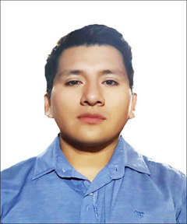

2 : Jakory Alexandra Huancas Coronel


CICLO ACADÉMICO : 2023 - I
Week 12 - Task: Assignment - How much are the batteries?

First Conversation:
“Clothes store”

Salesperson: Welcome to rasfari store Can I help you?
Customer: Good morning. Yes, please. I'm looking for a t-shirt.
Salesperson: We have different colors, some in particular?
Customer: I'm looking for a green t-shirt.
Salesperson: We do have it, what size do you want?
Customer: Medium size please, how much is it?
Salesperson: It’s $ 20 including tax.
Customer: Ok, I take it.
Salesperson: Great, you can pay by cash on delivery or visit our store.

Second Conversation:
“Shoe store”
Salesperson: Welcome to leather store Can I help you?
Customer: Good afternoon. I'm looking for some leather shoes for the winter.
Salesperson: We have different colors, some in particular?
Customer: Black color please.
Salesperson: What size do you want?
Customer: Do you have in size (42)?
Salesperson: Of course. It’s $ 20 including tax.
Customer: Ok, I take it.
Salesperson: Great, the payment methods are on our page, we are waiting for your payment. The delivery is free.
Customer: Thank you so much, goodbye.

