PANTONE 134C | PANTONE 135C
PANTONE 136C | PANTONE 137C
PANTONE 1345C | PANTONE 1355C
PANTONE 1365C | PANTONE 1375C
  PANTONE 100C | 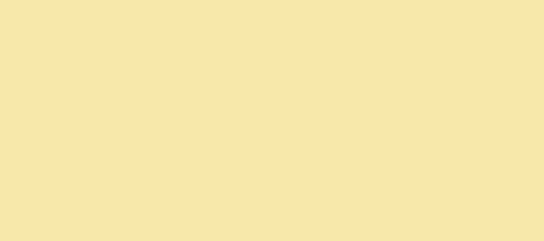  PANTONE 1205C

